**SACRED HEART GIRLS’ COLLEGE**

**OAKLEIGH**



**Mathematical Methods CAS 2013**

**Unit 4 SAC 4: ANALYSIS TASK**

**Part A**

**Name: ________________________________**

**Teacher (please circle)**: Ms Gates Mr Smith Mrs Mak

**CAS and a bound reference of summary notes permitted**

**Part A: ITEM ANALYSIS**

|  |
| --- |
| **Instructions:** For the questions below, clearly indicate the correct response with a tick. 1 mark will be awarded for each correct response and 1 mark will be awarded for providing valid reasons or explanations for why each of the other responses in the question is incorrect. |

**Question 1**

The approximation formula $f\left(x+h\right)≈f\left(x\right)+hf^{'}\left(x\right),$ where $f\left(x\right)=x^{3}$ with $x=5,$ when used to find an approximate value to ${4.95}^{3},$ gives

|  |
| --- |
| $f\left(0.05\right)+f(5)$ |
| $f\left(0.05\right)-5f'(0.05)$ |
| $f\left(0.05\right)+5f'(0.05)$ |
| $f\left(5\right)-0.05f'(5)$ |
| $f\left(5\right)+0.05f'(5)$ |

**Question 2**

The left rectangle approximation with rectangles of width 1 unit is used to find the approximate area of the region bounded by the $x-$ axis, the line $x=3$ and the curve with rule

$y=\sqrt{9-{\left(x-3\right)}^{2}.}$ The approximate area is

|  |
| --- |
| $\sqrt{5}$ |
| $\sqrt{5}+3$ |
| $\sqrt{8}+3$ |
| $\sqrt{5}+\sqrt{8}$ |
| $\sqrt{5}+\sqrt{8}+3$ |

**Question 3**

The graph shown has rule $y={\left(x+2\right)}^{2}(x^{2}-4x+6)$

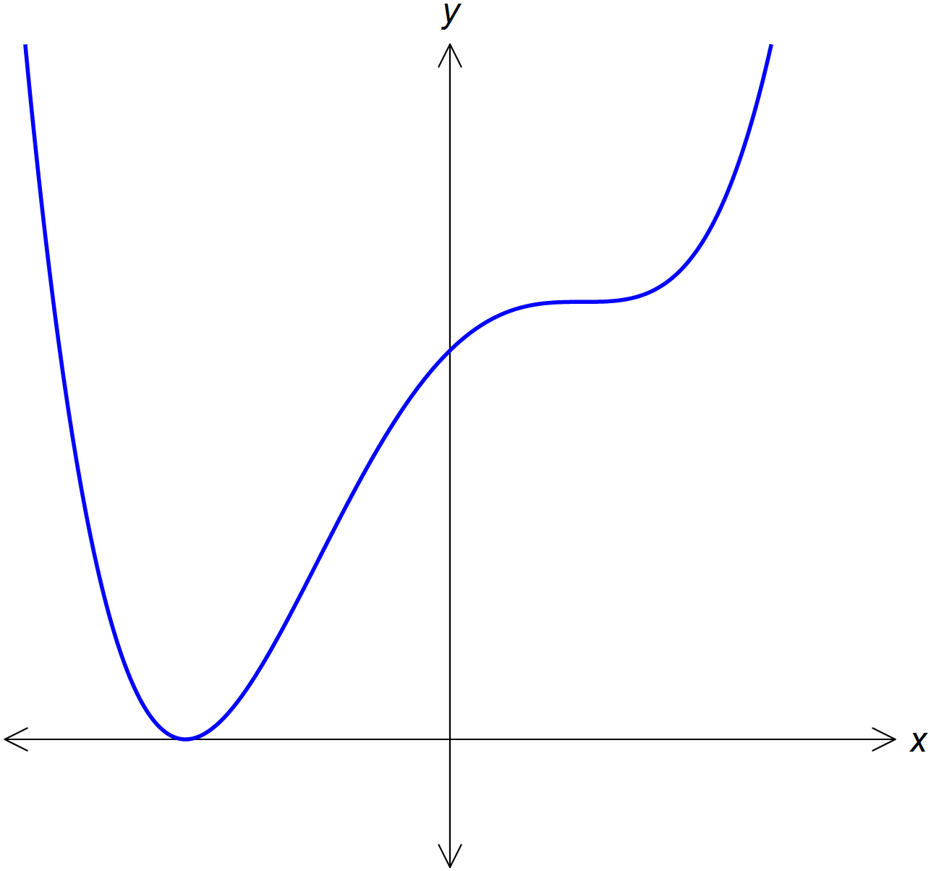

Which one of the following is **not** true?

|  |
| --- |
| 1. The gradient of the tangent to the graph at $x=1$ is zero. |
| 1. when and when and at no other point |
| 1. There is only one turning point on the graph |
| 1. There is only one stationary point on the graph |
| 1. for all values of $x$ |

**Question 4**

At the swimming pool, Linh goes as fast as she can down the water slide. She starts from rest at the top of the water slide.

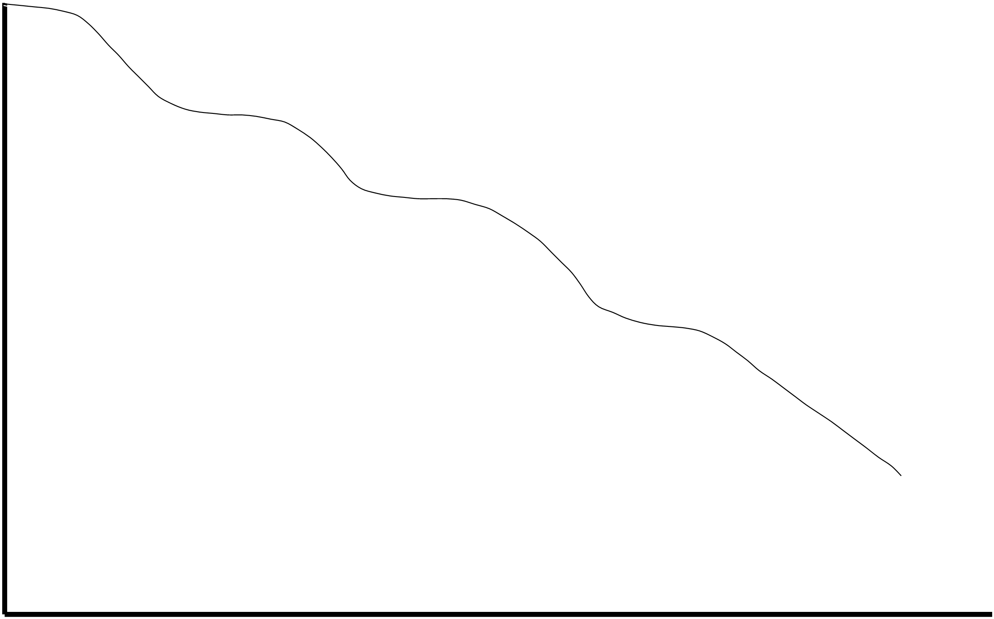

Which one of the following best represents Linh’s speed $\left(v\right)$ as a function of the horizontal distance travelled $(d)$.

|  |  |
| --- | --- |
|  |  |
|  |  |
|  |  |
|  |  |
|  |  |
|  |  |